**TASK 01:**

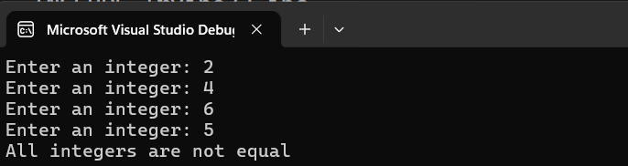

**TASK 02:**

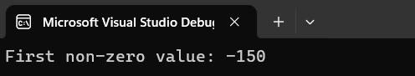

**TASK 03:**

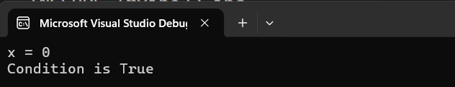

**TASK 04:**

**TASK 05:**

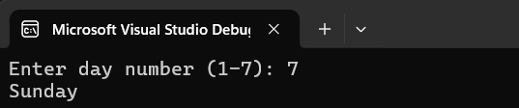

**TASK 06:**

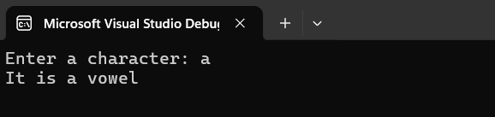

**TASK 07:**

**TASK 08:**

